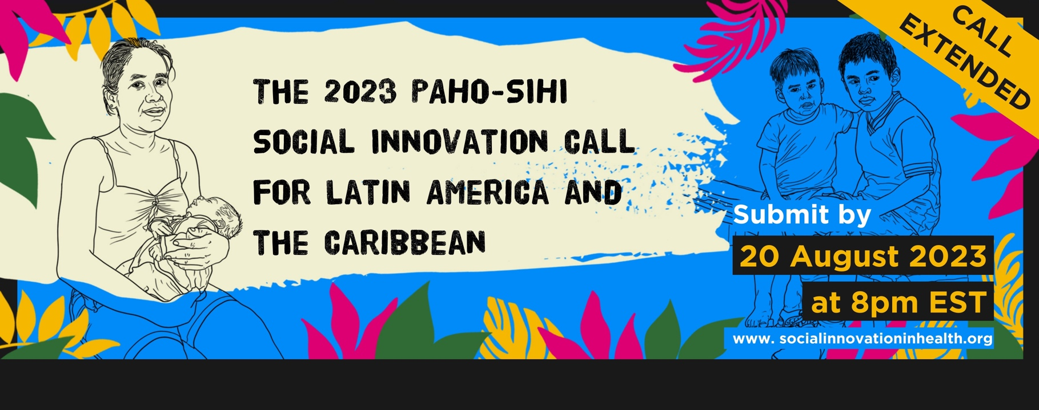

APPLICATION FORM

Q1 | BASIC INFORMATION
 | Name
 | Surname:
 | Email:
 | WhatsApp Number:
 | Name of your organization:
 | Name of your project:
 | Country of implementation:
 | Month & Year your project started:
 | How did you hear about this social innovation call?
Q2 | THE NEED:  Describe the extent of the need you are addressing and why this need matters to its beneficiaries or the community? ( max 300 words)
Q3 | THE STRATEGY:  What is the strategy that you have developed to address this need and what are its core components? (max 300 words)
Q4 | PARTICIPATION:  Who has been included and involved in the creation and implementation of this strategy? (max 300 words)
Q5 | COLLABORATION:  What relationships, roles and stakeholders play a key part in the success of this strategy?  (max 300 words)
Q6 | IMPACT:  How has this strategy closed the health equity gap (i.e. made it more fair or just)? What other outcomes has it achieved? If you have any data available, please share it.  (max 300 words)
Q7 | SUSTAINABILITY:  How has your strategy unlocked or how has your strategy used resources (finances, time, people etc.) to make it affordable and sustainable? How has your strategy has been funded?  (max 350 words)
Q8 | SCALABILITY:  How has, or could this strategy be integrated into the health system and/or replicated/ adapted to other similar settings?  (max 300 words)
Q9 | SYSTEMS CHANGE:  How does this strategy challenge the status quo and how could it positively disrupt the health system?  (max 300 words)
Q10 | EXTRA INFORMATION:  Please provide links to any available reports, publications or news pieces about the innovation.
Q11 | LETTER OF RECOMMENDATION –  Please provide a letter from an individual or organization not directly involved in this solution.
Q12 | VIDEO:  Please share a short (3-minute) personally recorded video, telling us why you think that your work matters and why you believe it deserves recognition by the global community? Send us the file or provide us with a link to your video.

Would you like to continue receiving information from SIHI LAC, such as events, funding opportunities and/or news related to social innovation in health, community health and related topics?
v

YES NO
v

I authorize CIDEIM to process my personal data for academic purposes and the processing of sensitive information, as established in Law 1581 of 2012 and Decree 1377 of 2013 and I agree with CIDEIM's Personal Data Processing Policy found at the following link:
https://www.cideim.org.co/cideim/images/documentos/institucional/politica_de_tratamiento_de_datos_personales_cideim.pdf
v
v

YES NO

If you have any questions, please reach out to us at sihilachub@cideim.org.co

