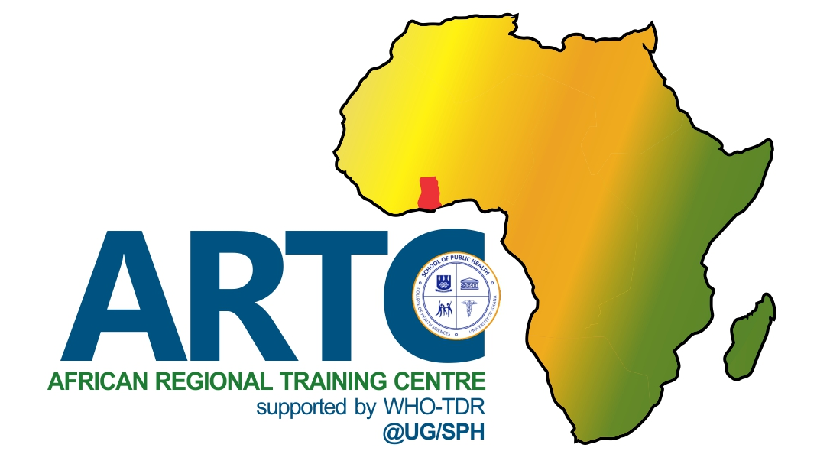
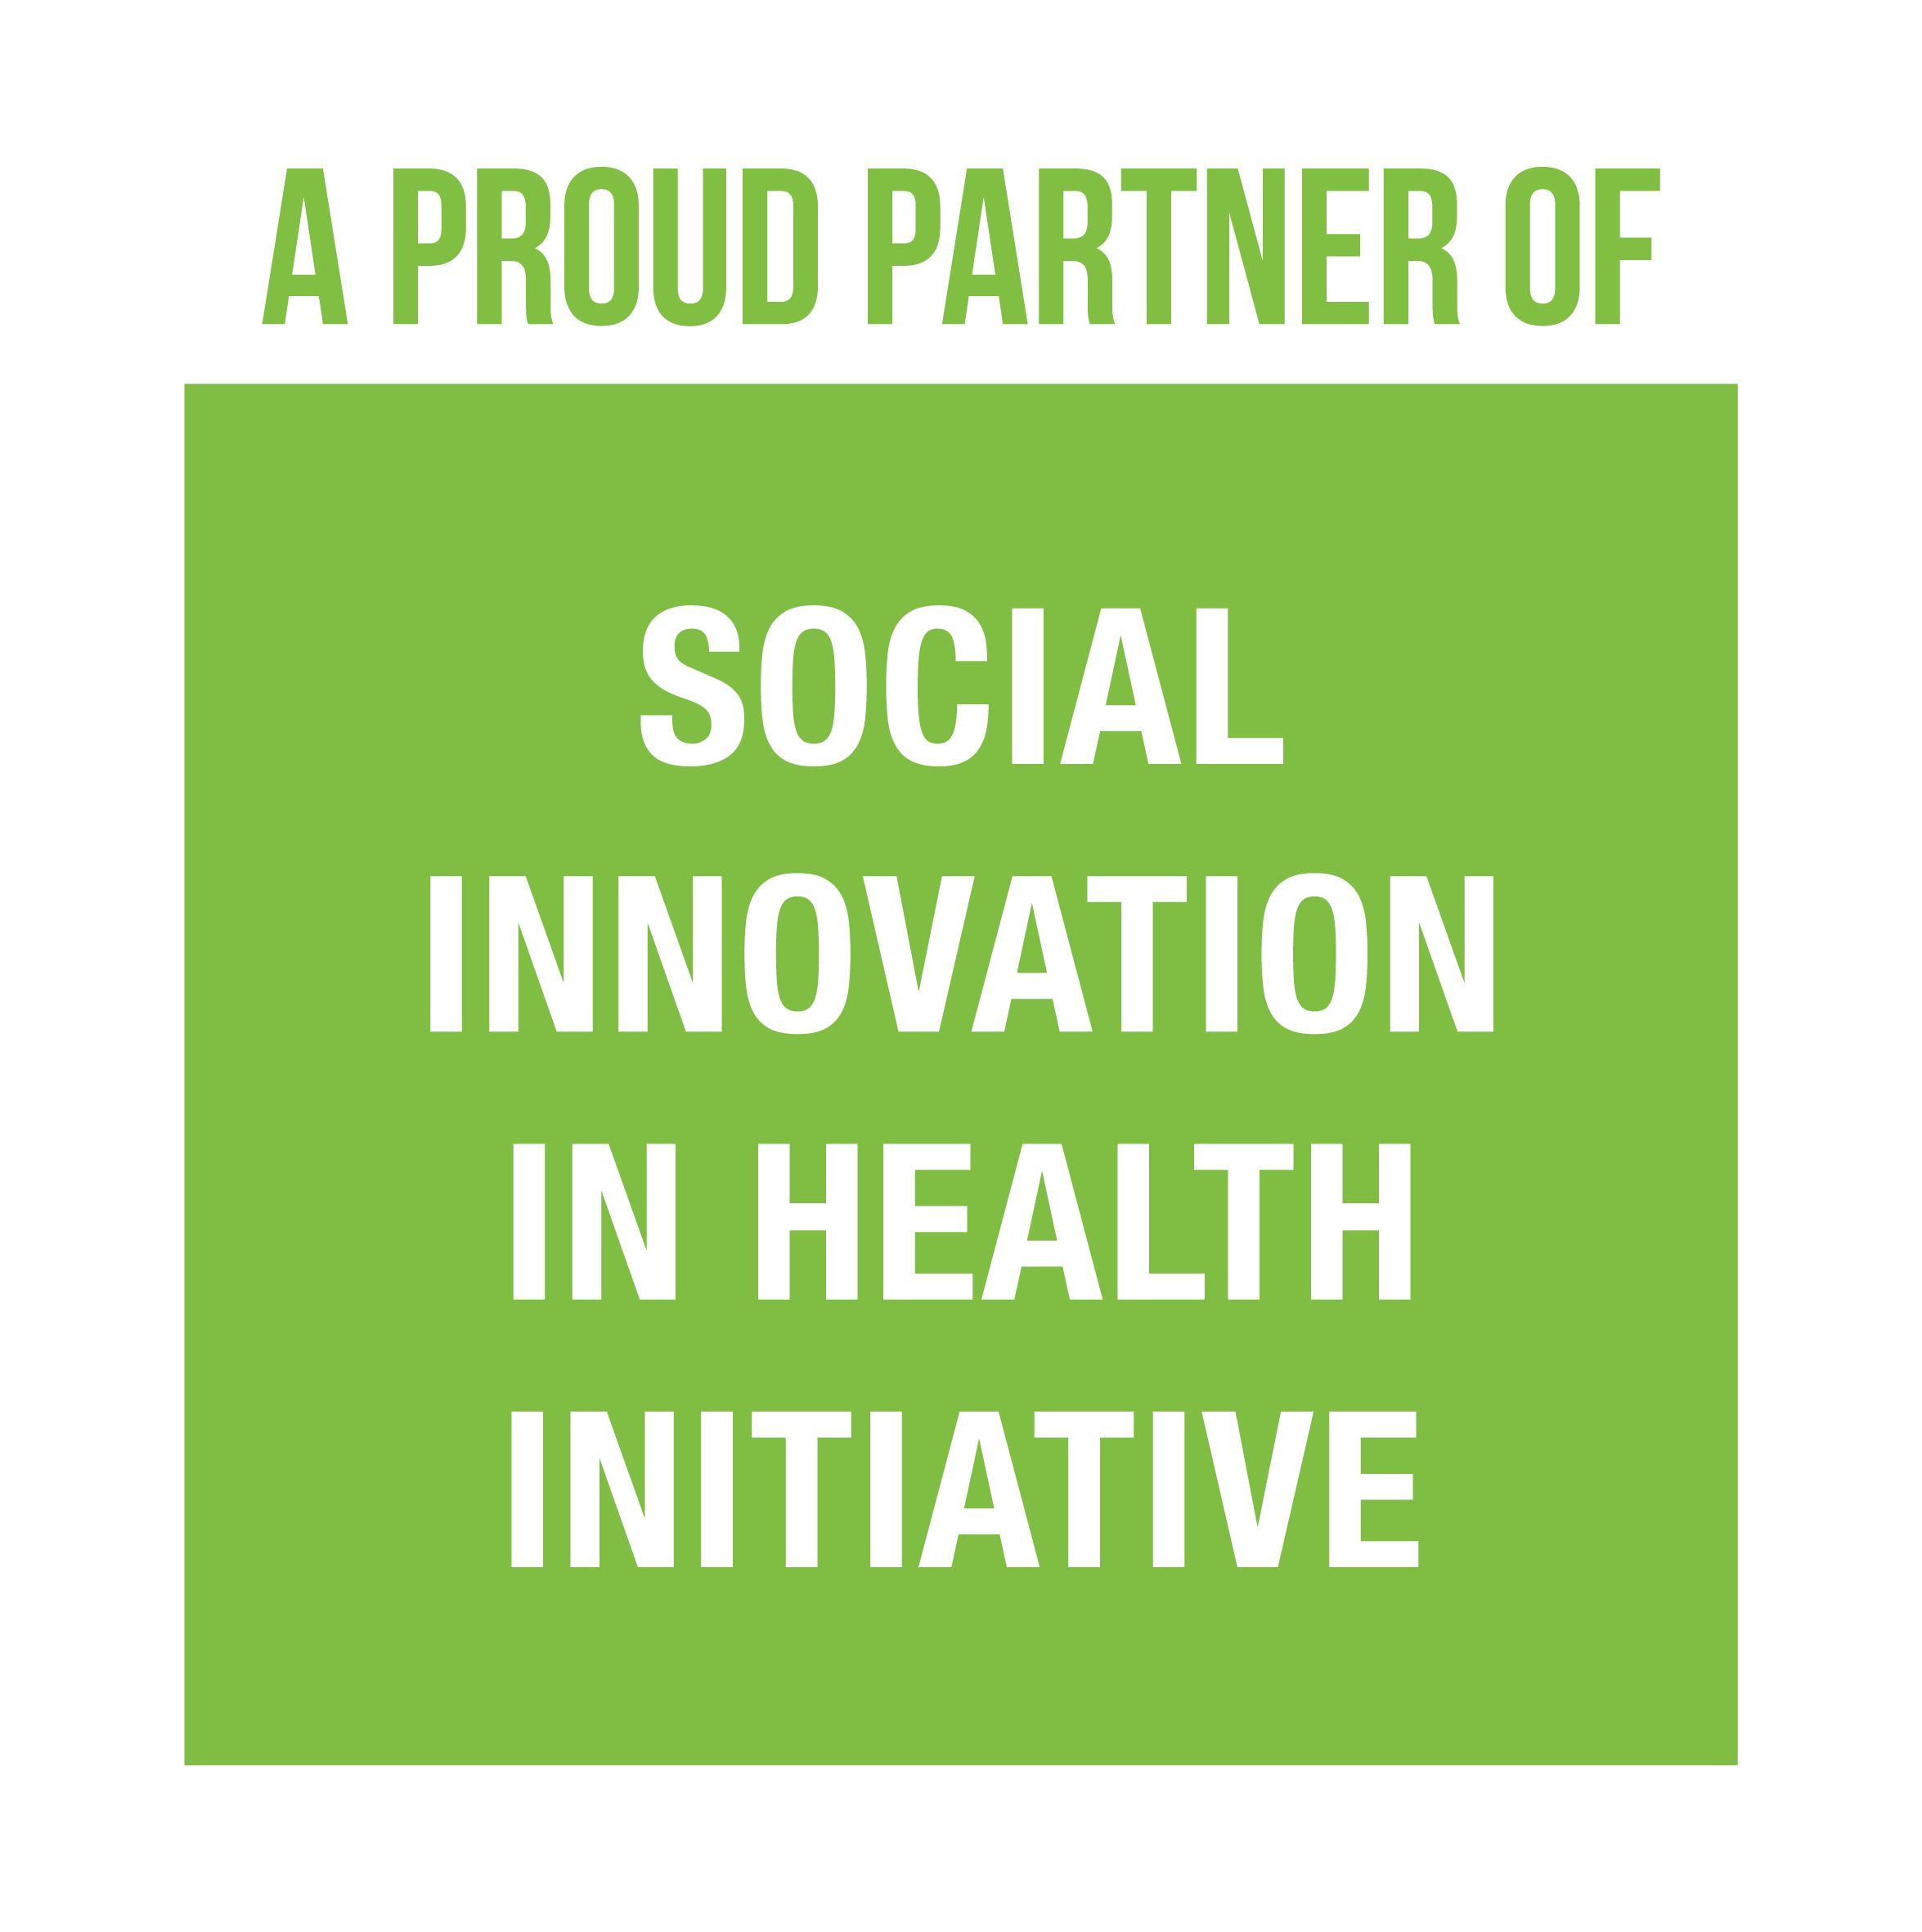


Thank you for wanting to share your solution with us! We are excited to learn more about your innovative work. Please complete the form below and send the completed form to ghana@socialinnovationinhealth.org

IF YOU HAVE ANY QUESTIONS, PLEASE CONTACT US: ghana@socialinnovationinhealth.org

PART 1

Please complete the information in the tables below. This will provide us with a basic overview of you, the founder, your project and the organisation who is implementing this project.

SECTION 1. DETAILS OF PERSON SUBMITTING THE SOLUTION

1 | Last name
2 | First name
3 | Title (Mr, Mrs, Ms, Dr, Prof)
4 | Organisation of employment
5 | Job Title
6 | Contact number
7 | Email address
8 | How did you hear about the call for solutions? (please select which way – email received; SIHI website; other website; newsletter; poster; radio; event, newspaper; other)
9 | If you heard in other ways, please specify

SECTION 2. DETAILS OF FOUNDER (the person responsible for creating the solution)

Please complete the information in the table providing information about the founder of the solution

10 | Last name
11 | First name
12 | Title (Mr, Mrs, Ms, Dr, Prof)
13 | Nationality
14 | Country of residence
15 | Gender (female / male/ prefer not to say)
16 | Current involvement in the solution delivery (actively involved; advisor; not involved)
17 | Current age (< 30; 31 – 45; 46 – 60; >60)
18 | Professional background of the founder: please submit a brief description below of their educational and professional background. (max 150 words)

SECTION 3. DETAILS OF THE SOLUTION

19 | Name of the solution
20 | Countries where the solution is implemented (list all)
21 | For how long has the solution been active (0 – 1 year; 1 – 3 years; 3 – 5 years; > 5 years)
22 | Size of the implementing team of the solution?
23 | Which area of focus best describes the solution? (prevention of disease, access to care, quality of care, community engagement, affordability, other)
24 | If other, specify
25 | Which disease category is the focus of the solution? (non-communicable disease; infectious disease (excl HIV, TB, malaria); maternal & child health; primary health care; HIV; TB; malaria; other
26 | Who are the target beneficiaries of the solution?
27 | Primary source of funding for the solution (>50%) (revenue, grants, government subsidies, other)
28 | If other, please specify
29 | Does the solution have a revenue generating component? (Yes/No)
30 | Is the local community engaged I delivering the solution? (Yes/No)
31 | Does the solution have any established relationship with the public sector? (Yes/No)
32 | Has any formal external evaluation been done of the solution? (Yes/No)

SECTION 4. DETAILS OF THE ORGANISATION

33 | Name of the organisation (within which your solution is based)
34 | Founding year of the organisation
35 | Main country of operation
36 | What is the size of the organisation (number of people employed) (0-10; 10 – 50; 50 – 100; >100)
37 | What is your organisational structure? Select from list below:  (government agency; hospital; university; company; non-governmental organisation, social enterprise; charity; voluntary organisation)
38 | What is your profit status?  Select from list below: non-profit, for-profit, hybrid
39 | What is your project / organisation website?

PART 2

SECTION 5. THE SOLUTION

Please provide us with a written description for each question. The text in green is to guide you as to how best to answer the question. Please pay attention to the word limit for each question.

40 | What problem in healthcare are you addressing?
In your answer, you may find it useful to consider the following:
- What is the specific health challenge you are addressing? Is it focussed on a disease or a general aspect of care?
- What is the scope of this challenge in your country? (please substantiate with country data if available)
- Please explain how your solution is addressing the focus area of this innovation call?
- Lack of access to healthcare services (including treatment)

 | ANSWER: 200 words max

41 | Describe your solution, how it was created and how it is being implemented?
In your answer, please address the following:
- What is the aim of your solution?
- Please describe the various components of your solution
- How long has your solution been implemented for and what is the scope?
- Who was involved in creating your solution?
- How is the local community involved in the creation or implementation of the solution?
- Who else is involved in the delivery of your solution?
- Do you have any partnerships with the Ministry of Health?
 | ANSWER:500 words max

42 | How do you think your solution is creative, innovative or different in your context?
In your answer, you may find it useful to consider the following:
- How is this solution different from what other people are doing in your context?
- What is the potential of this solution to transform the health system of your country?

 | ANSWER: 300 words max

43 | Describe the positive impact your solution has achieved in improving healthcare (please provide any measurable data or evaluation studies if available)
In your answer, you may find it useful to consider the following:
- How do you measure the impact of your solution – how do you know it is working?
- How many People have you reached so far?
- What has been the outcome on the health of the people whom your solution serves?
- You can provide us 1-2 individual stories about people who have been impacted by this solution or provide us with some data you have collected
- Other aspects of social transformation
 | ANSWER:500 words max

44 | Describe the affordability of your solution
In your answer, you may find it useful to consider the following:
- How does the cost of your solution compare to an existing alternative in your country?
- How many People are employed in the delivery of your solution and what is the annual cost of providing this solution?
- If there isn’t an existing alternative, how affordable is your solution compared to a standardised income metric (for example the minimum daily wage for the community in question)?
 | ANSWER: 500 words max

45 | What aspects of your solution could be scaled or replicated to other areas in the country or to other countries?
In your answer, you may find it useful to consider the following:
- Has your solution been implemented in more than one setting? If yes, please expand.
- What aspects of your solution can be scaled?
- To scale your solution, what would you need?
- To which areas or countries could your solution be replicated – why?
 | ANSWER:500 words max

46 | Describe how you are able to sustain your solution?
In your answer, you may find it useful to consider the following:
- Is your solution dependent on grants, donations or do you have a revenue stream?
- If you have a revenue stream, please describe it.
- How has your solution been integrated into the community or adopted in other settings?
- What socio-cultural and/or environmental factors might help the solution to persist in time?
 | ANSWER:500 words max

THANK YOU FOR SUBMITTING YOUR SOLUTION!

